Task 3 - P

Design and deploy model using

Azure machine learning

Saurabh Dharmadhikari

Saurabh.dharma01@gmail.com

Survival prediction on

Titanic dataset

|  |  |
| --- | --- |
| Question 1. **For this task you need to design and deploy a machine learning model using Azure ML studio (designer). You need to use Microsoft Azure Machine Learning Studio to design and deploy your model. To complete this task, you need to select a dataset and design a decision tree model (classification tree or regression tree) and then deploy the built model and get the API key. To do this task you need to follow the workshop recording and slides and deploy your own model on Azure. You need to provide the screenshots of your designed model, training model, the performance of the built model (e.g., Accuracy, confusion matrix and etc) and deployed model with the API key and test the model. The screenshot of the model should include your Azure account name since the API key is unique to you.** | 2 |

Table of Content:

1. **For this task you need to design and deploy a machine learning model using Azure ML studio (designer). You need to use Microsoft Azure Machine Learning Studio to design and deploy your model. To complete this task, you need to select a dataset and design a decision tree model (classification tree or regression tree) and then deploy the built model and get the API key. To do this task you need to follow the workshop recording and slides and deploy your own model on Azure. You need to provide the screenshots of your designed model, training model, the performance of the built model (e.g., Accuracy, confusion matrix and etc) and deployed model with the API key and test the model. The screenshot of the model should include your Azure account name since the API key is unique to you.**

Introduction:

We have used titanic dataset to build a decision tree in Microsoft Azure Machine Learning Studio.

The below is the image showing the pipeline of building this model.

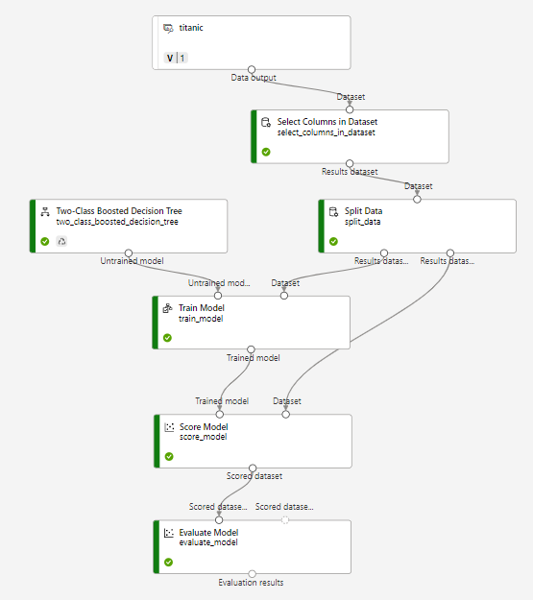

First of all we create a resource group called MDS-deakins with location as Central India.

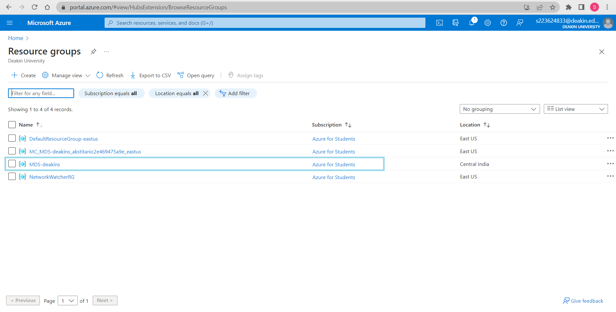

After creating the resource group, we create resource group we create a new Azure machine learning under the resource group we created.

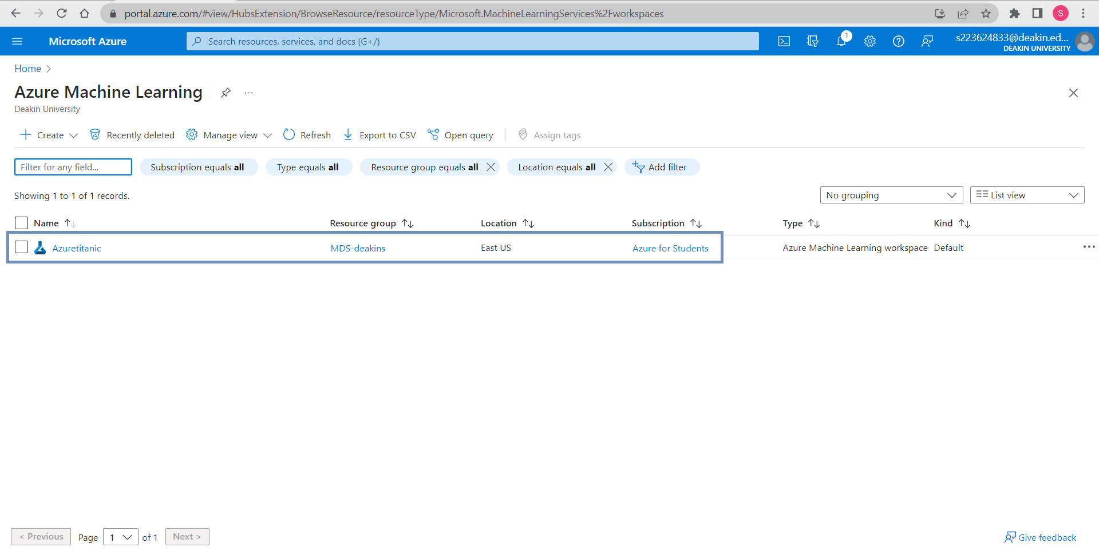

WE have created a work space in Azure machine learning.

We then launch studio and we create dataset in this environment using data option in designer.

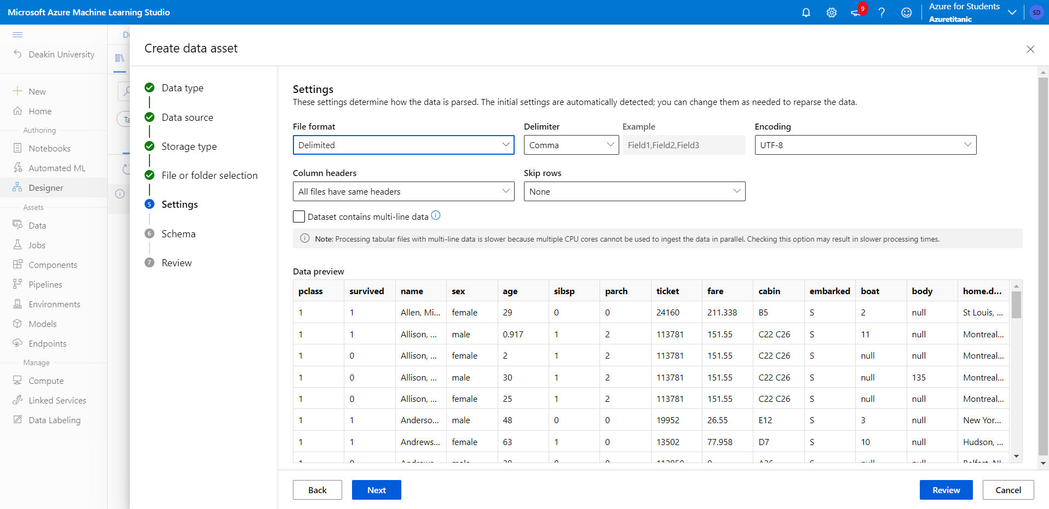

We have taken this data set from our local computer and in the above image we can see a preview of the dataset.

We can now drag and drop the dataset created in our work space to build a pipeline.

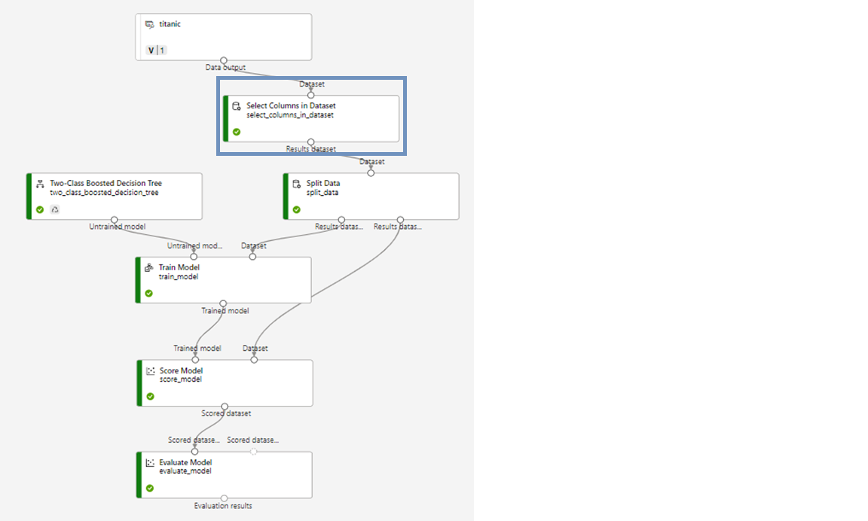

We then drag and drop Select Columns in Dataset from the component option in designer and connect it to dataset.

We select a total of 8 features in the Select Column in Dataset, namely:

1. **pclass**
2. **survived**
3. **sex**
4. **age**
5. **sibsp**
6. **parch**
7. **fare**
8. **embarked**

Including our target variable i.e., survived

We now drag and drop split data option from component and split the data into 80:20 ratio. Where 80 will be our train data and 20 will be our test data.

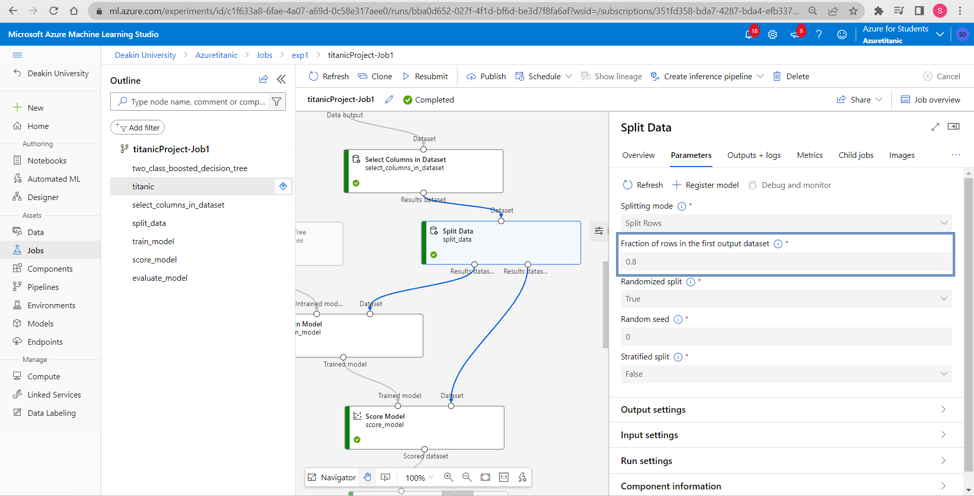

After splitting the data, we drag and drop Two-Class Boosted Decision Tree here under parameters we have specified that:

1. Max number of leaves pre tree: 20
2. Min number of samples per leaf node: 10
3. Learning rate: 0.2
4. Number of trees constructed: 100

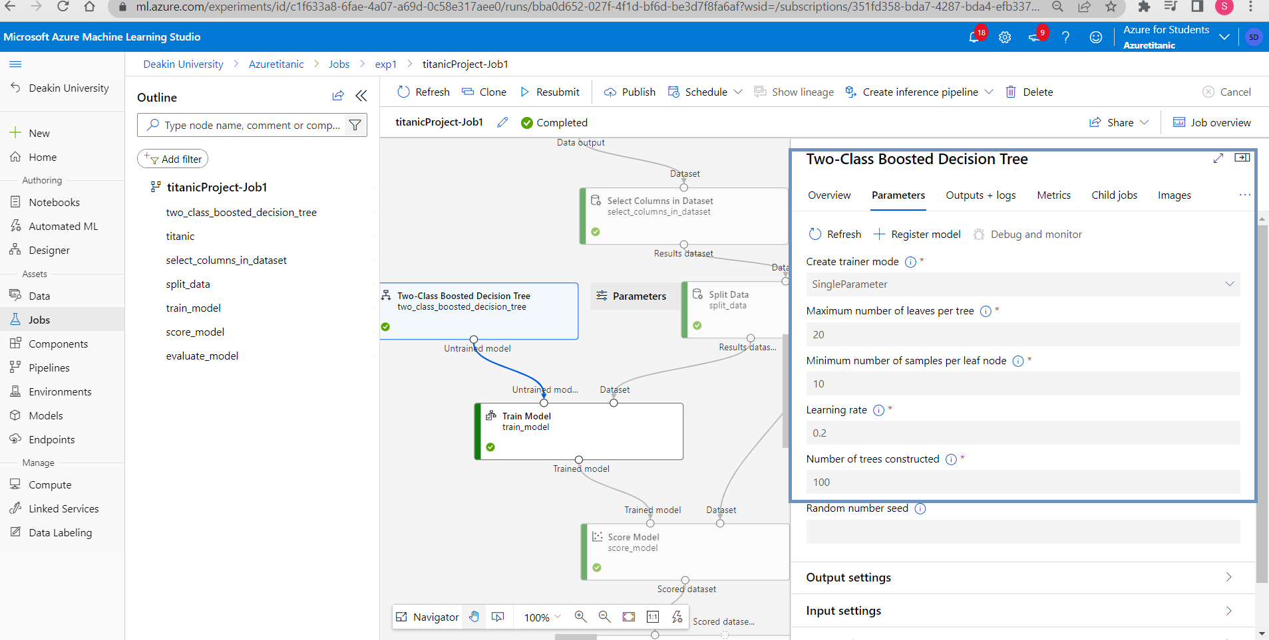

Hereafter we drag and drop train model and specify the label column as survived. We connect it to Two-Class Boost Decision Tree from where it takes the model for prediction and Split data from where it takes the train set.

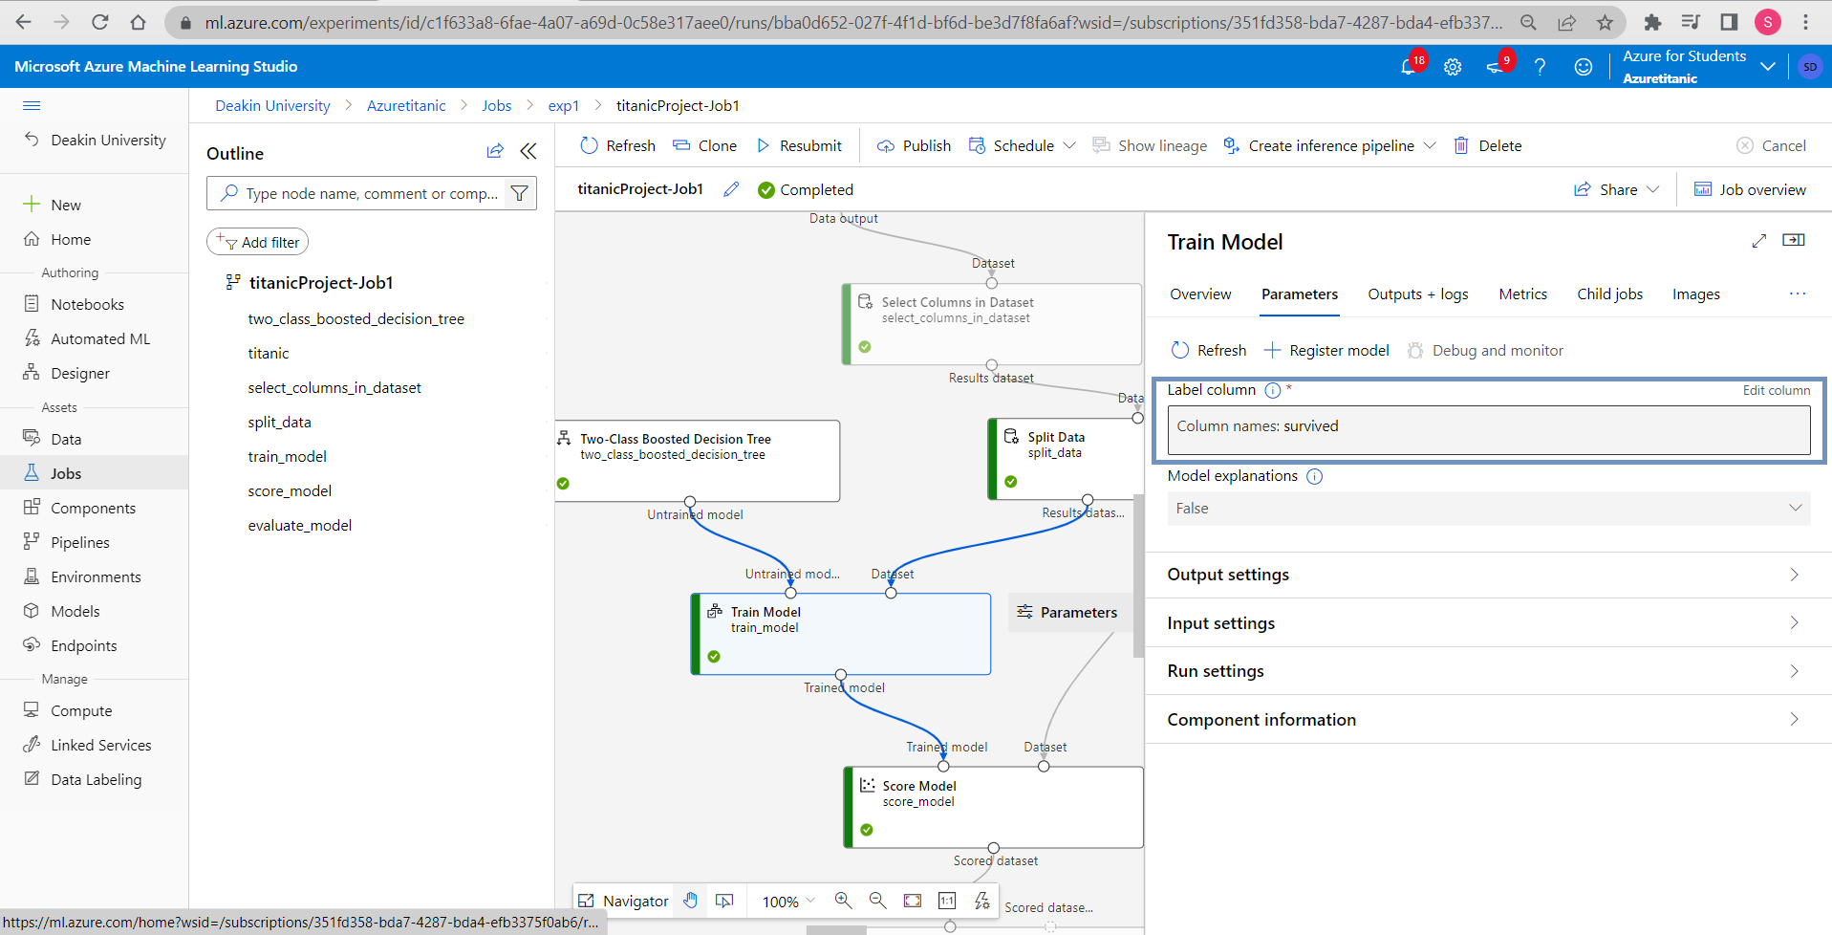

Also, we drag and drop score model and connect it with train model and split data to feed it both the trained model and test model. Also, we drag and drop evaluate model and connect it to score model.

Now our pipeline is complete. We save this pipeline.

We now go to the compute option from the side bar and create a compute cluster named comclusterTitanic with location east US and 1 node.

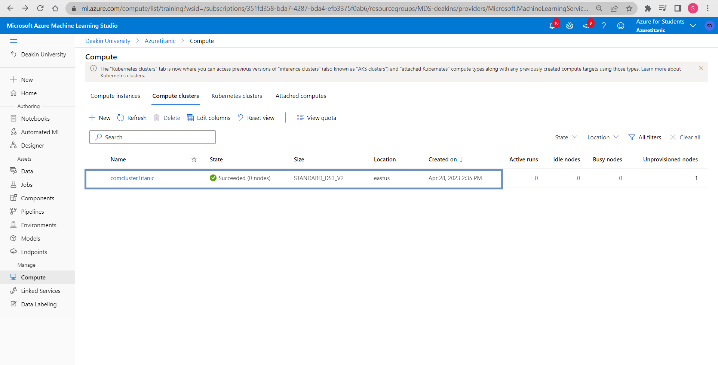

We go back to designer in our pipeline that we saved earlier and click settings on right side of the screen. Here we specify the cluster we created in the previous step and click submit.

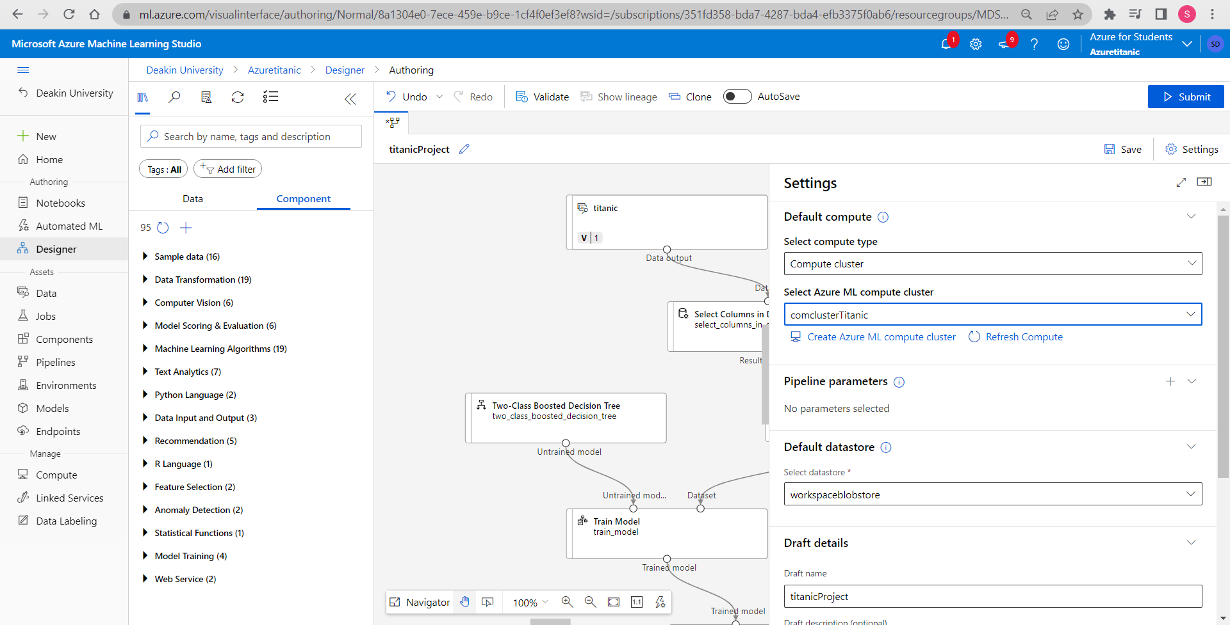

We name the experiment as exp1 and also give it a display name and click on submit.

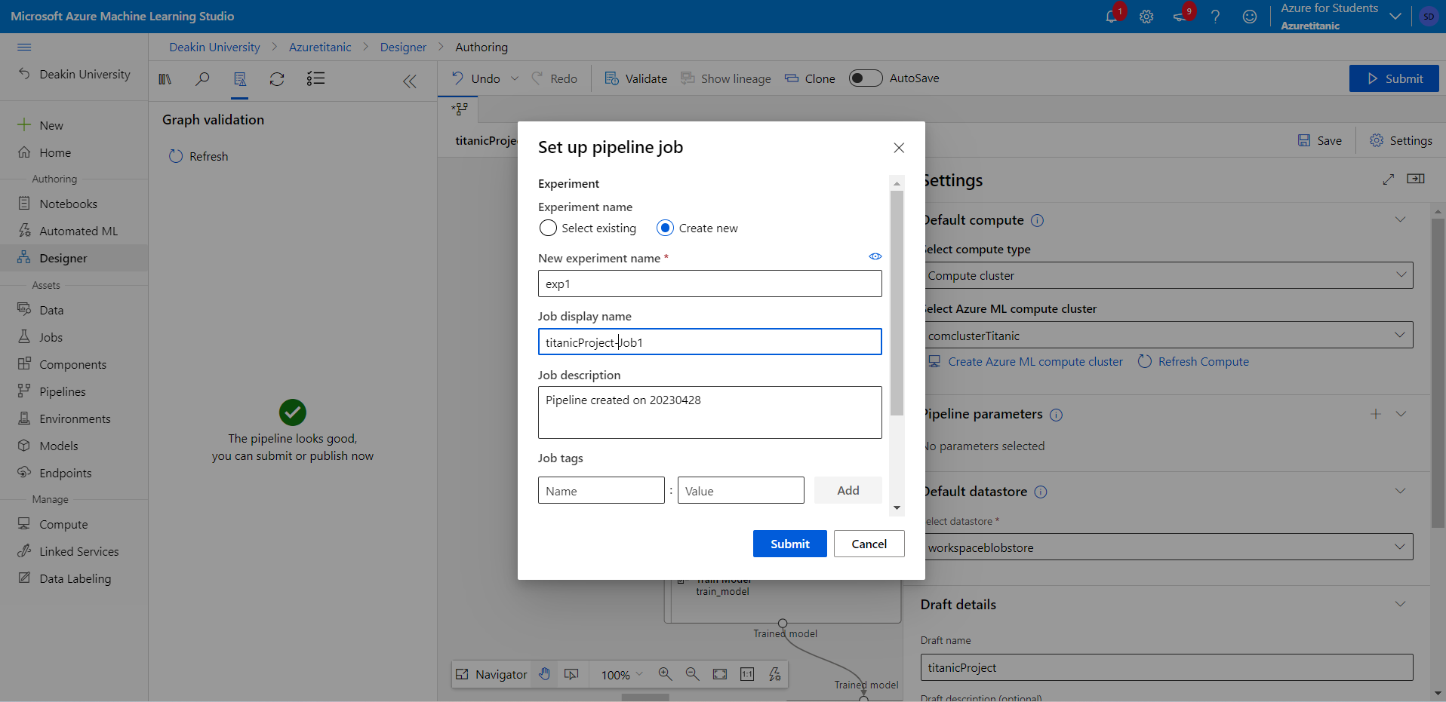

exp1 is created in jobs now so we go to jobs and click on exp1, we can see that the model is trained now.

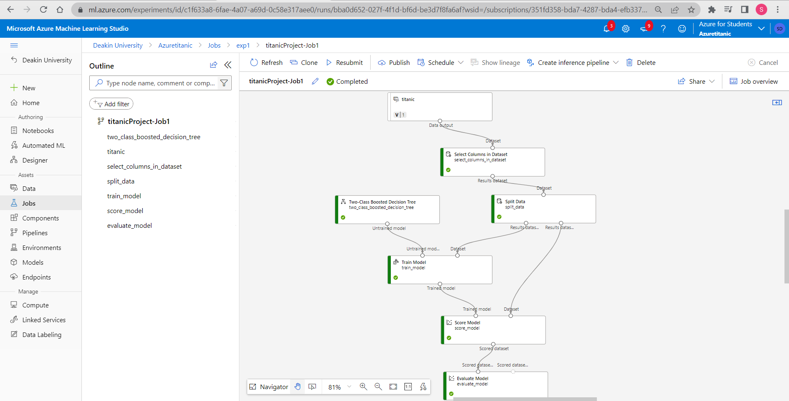

We then double click on train model and download samplejson, conda dependencies and score.py.

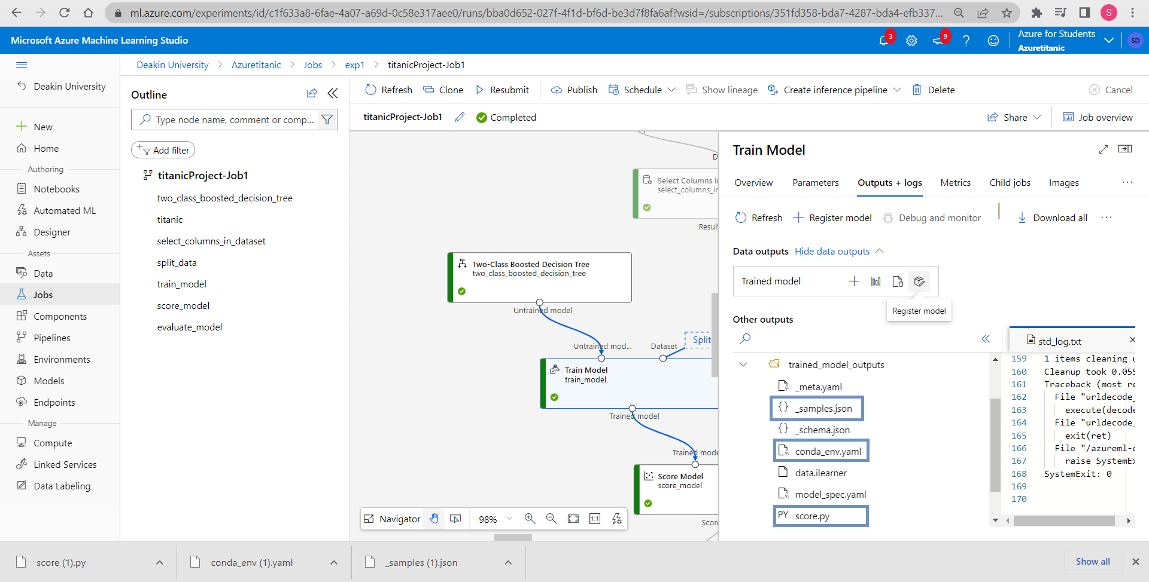

Now we register the model as Azuretitanicml.

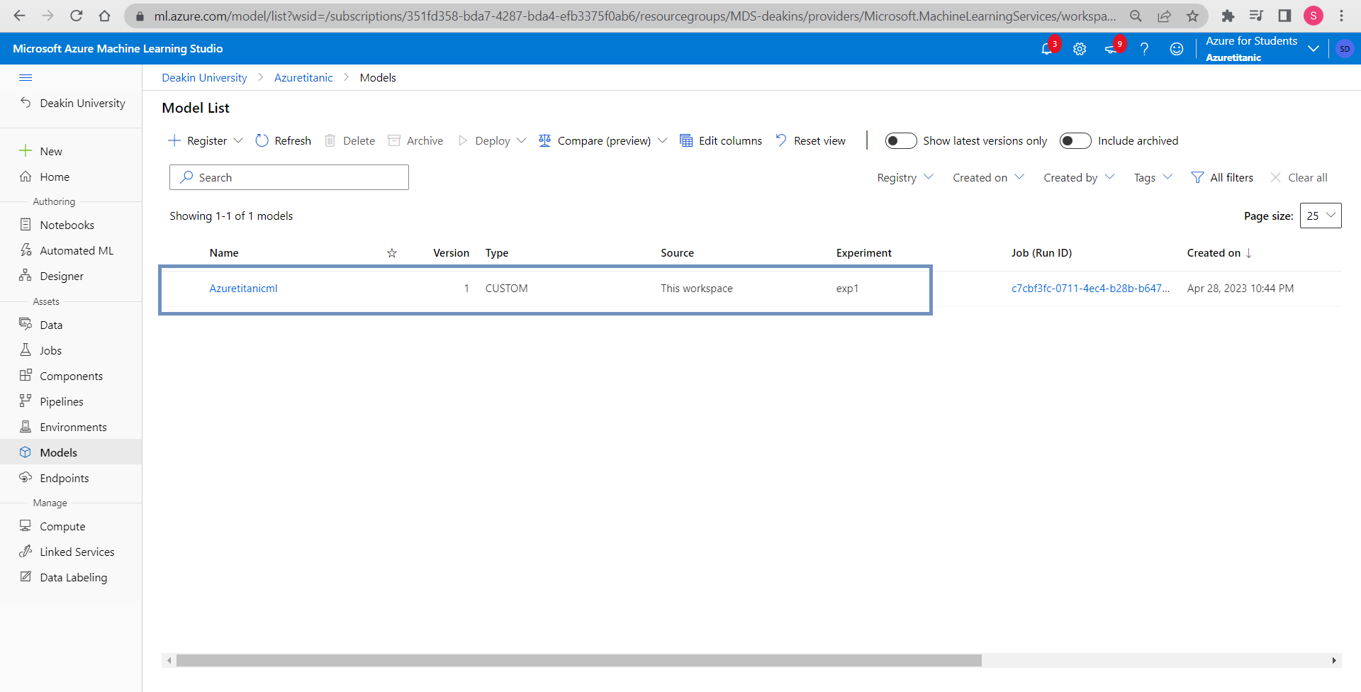

We can find the registered model in models option.

We will first create a Kubernetes cluster before deploying the model as shown below. Kubernetes cluster is named Akstitanic that we created for deployment.

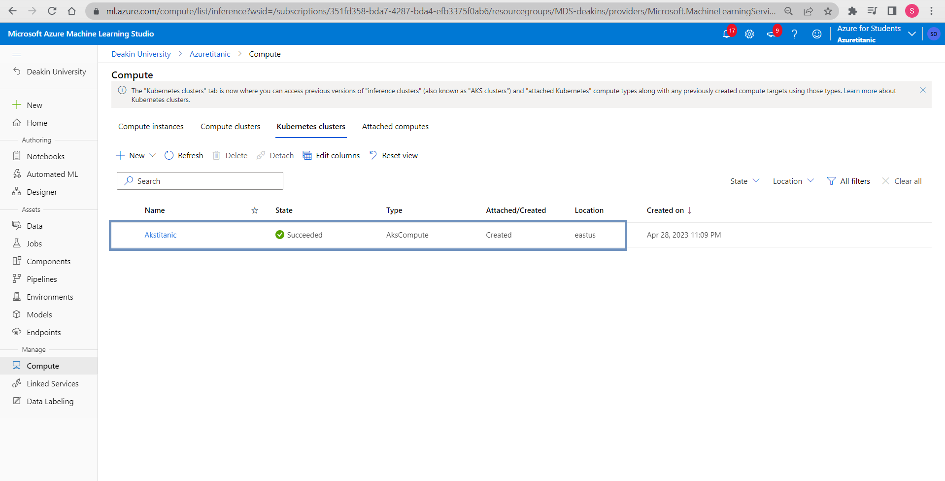

We find the model created earlier in models after we enter the model, we can deploy it as webservice.

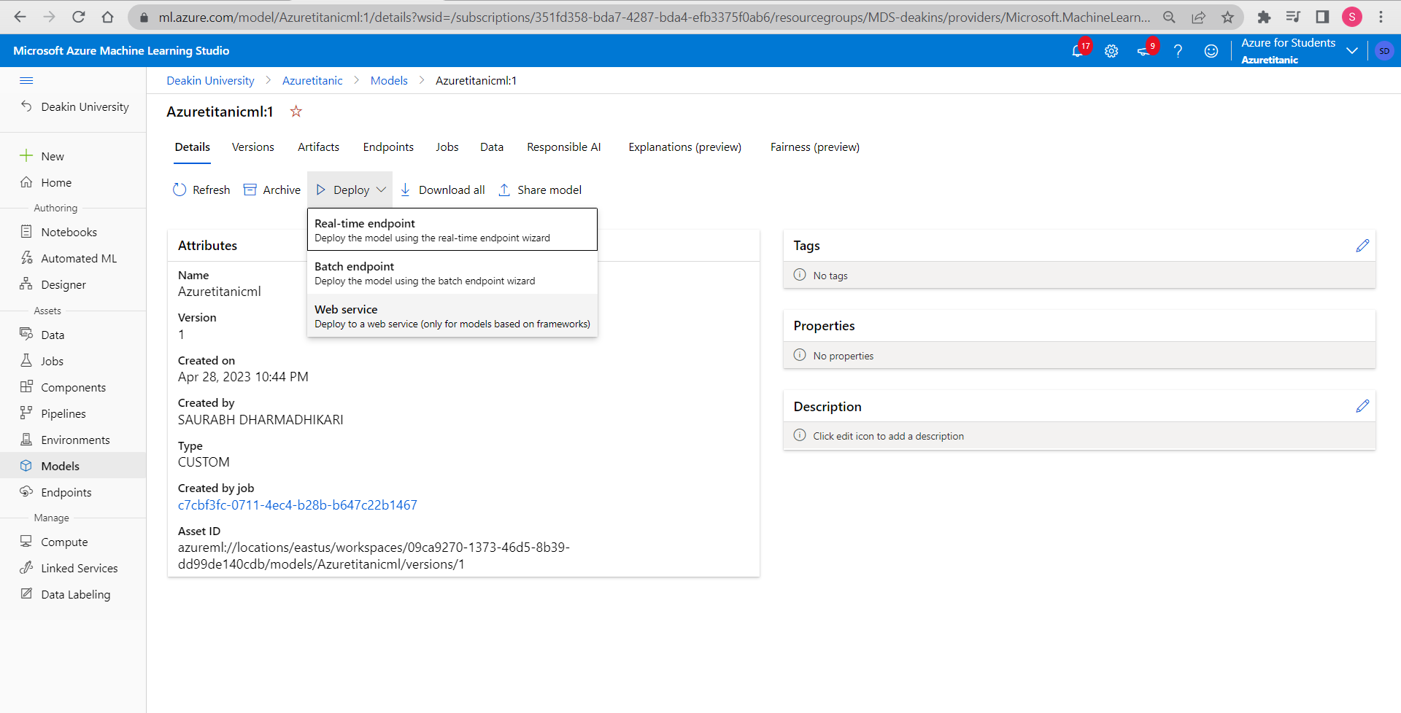

We put compute name as Akstitanic.

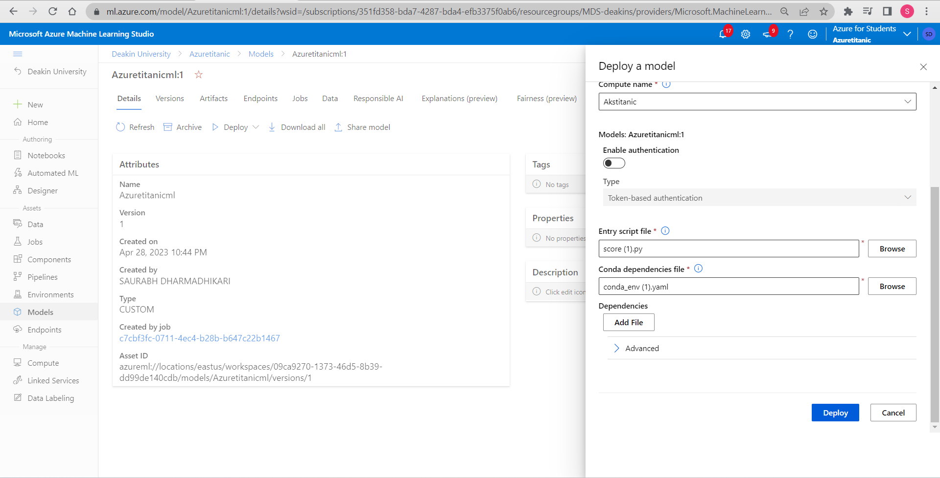

Once deployed we can now evaluate and check the performance of the model that we created.

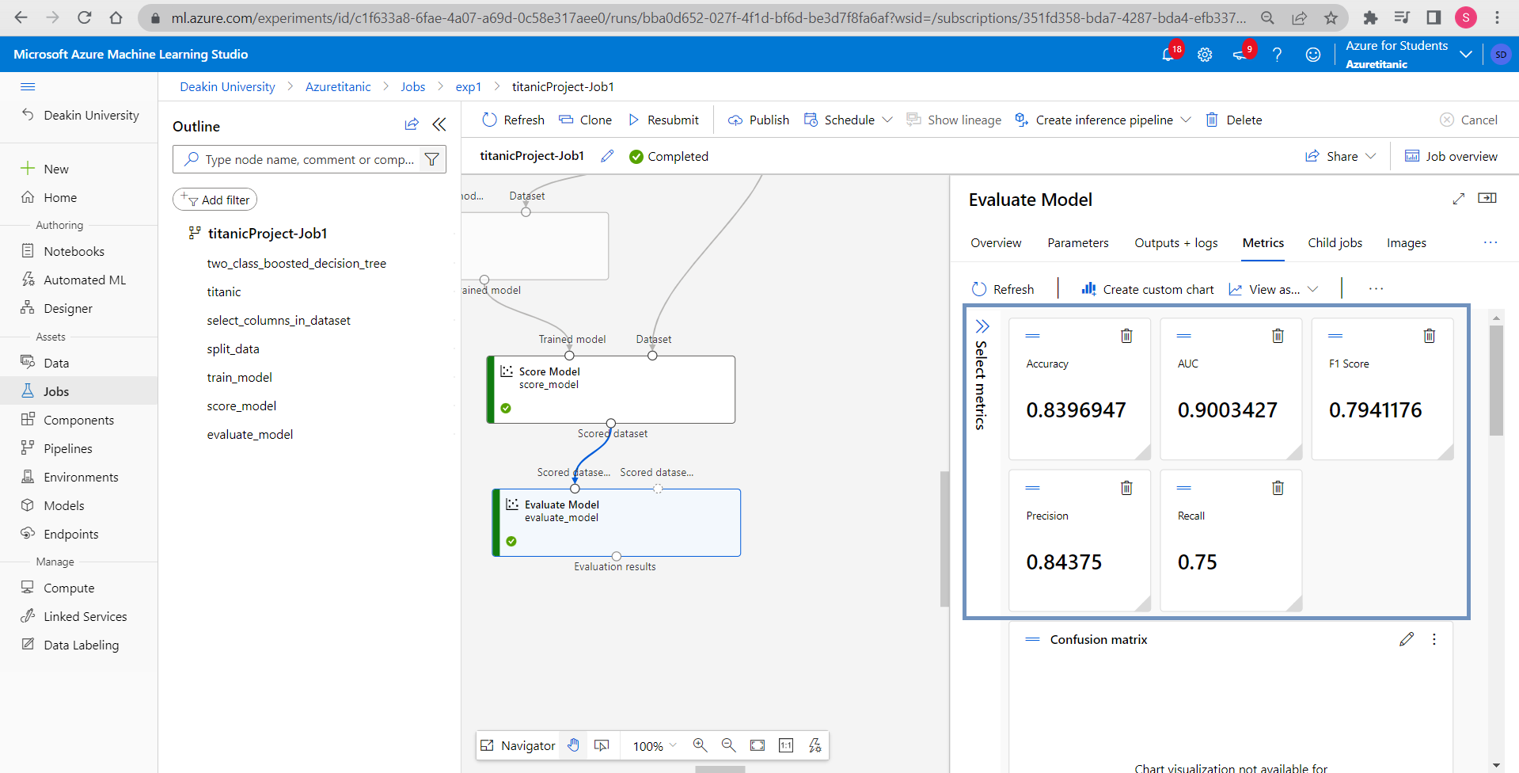

Double click evaluate model and after we click metrics we can understand the performance of the model that we created.

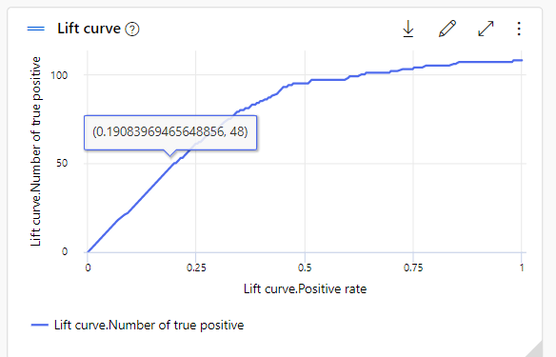

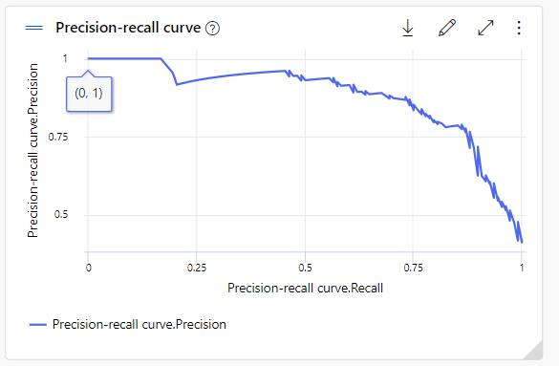

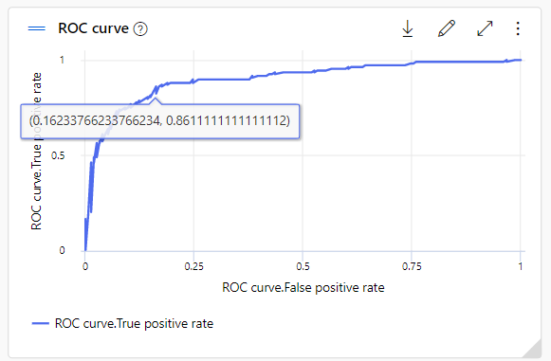

In the endpoint option we can find REST API endpoint required by the developer.

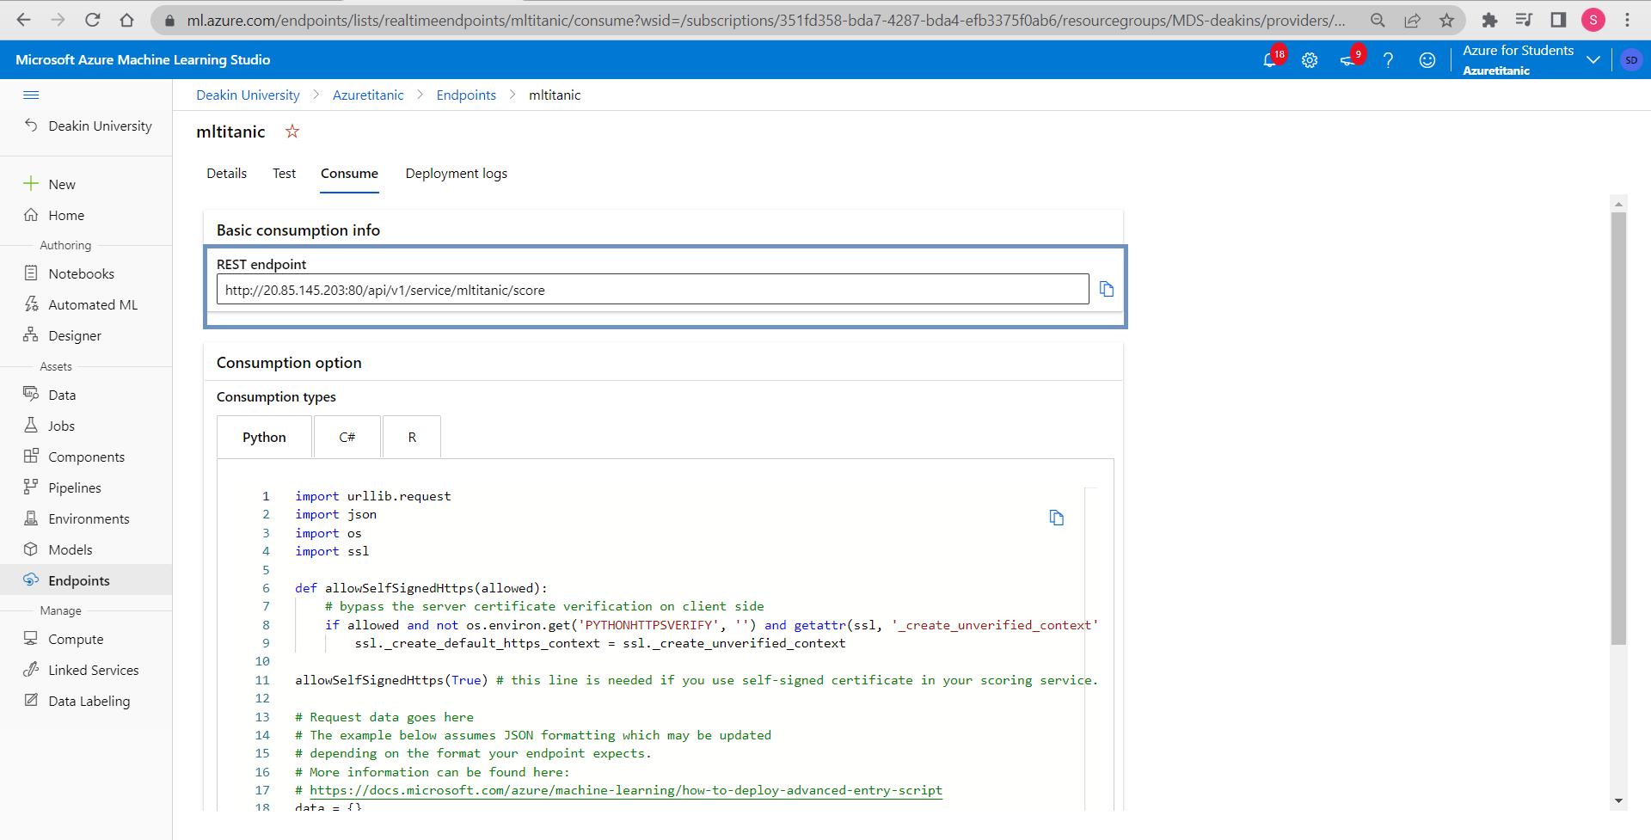

We can also find the codes in different languages here.

**References**

No references were taken.